HARDEMAN FAYETTE UTILITY DISTRICT
DEBIT AUTHORIZATION

I (we) hereby authorize Hardeman Fayette Utility District to initiate debit entries to my (our) account indicated below and the Bank of Fayette County, hereinafter called Financial Institution, to debit the same to such account. I (we) acknowledge that the origination of ACH transactions to my (our) account must comply with the provision of U.S. law.

_____________________________________________________________________________________
Financial Institution Name Branch

_____________________________________________________________________________________
Address City/State Zip

_____________________________________________________________________________________
Routing Number Account Number Checking _____ Savings _____
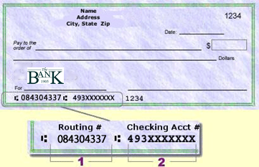

This authority is to remain in full force and effect until Hardeman Fayette Utility District has received written notification from me (or either of us) of its termination in such time and manner as to afford Hardeman Fayette Utility District and Financial Institution a reasonable opportunity to act on it.

_____________________________________________________________________________________
Print Individual Name Signature

_____________________________________________________________________________________
Print Individual Name Signature

Hardeman Fayette Utility District Customer Account Number (s): _________________________________

: _________________________________
PLEASE ATTACH COPY OF A VOIDED CHECK TO THIS FORM

NOTES:

All written credit authorizations must provide that the Receiver may revoke the authorization only by notifying the Originator in the manner specified in the authorization.

The credit is limited to one attempt from Hardeman Fayette Utility District. If the funds are not available on the first attempt at your Financial Institution, you will have to present your payment to Hardeman Fayette Utility District by other means.

Single – entry reversals do not require authorization by the Receiver. Therefore, previously recommended language regarding the initiation of possible credit entries is no longer stated in the authorization.

The underlined language in the authorization above represents the disclosure requirement associated with the clarification of OFAC economic sanction policies upon ACH Network Participants.

